**The Recruitment Methods of Tesco Plc**

**Introduction to Tesco PLC:**

Established by Jack Cohen in 1919, Tesco PLC has grown into a multinational retail conglomerate with operations across multiple nations. With its headquarters located in Welwyn Garden City, England, Tesco has expanded from small beginnings to become one of the biggest and most prosperous retail chains in the world. With a long history spanning more than a century, Tesco is still dedicated to offering millions of consumers globally premium products and first-rate service.

Tesco PLC manages a wide variety of retail spaces, such as convenience stores, supermarkets, hypermarkets, and online marketplaces. Tesco provides a broad range of products to satisfy the needs of its consumers, whether they are for food, household goods, apparel, electronics, or financial services. Tesco focuses on accessibility and cost to provide value and convenience.

**Why would Tesco recruit?**

Tesco may hire new workers for a variety of reasons, but addressing staff mix is a key consideration. There are many varied reasons why employees leave their jobs, including personal situations, career progress, Death, and relocation. Tesco wants to fill these positions as soon as possible to preserve operational effectiveness and guarantee flawless customer service. Additionally, hiring more staff is crucial to meeting the rising demand and upholding good service standards if Tesco is growing its commercial operations, whether through the opening of new stores or the diversification of its offerings. Consequently, Tesco uses recruitment as a strategic drive to restock its personnel and further its goals for continuous development and expansion.

Tesco may also hire inexperienced staff members to infuse the company with new ideas and abilities. Maintaining creativity and flexibility in a cutthroat retail environment is essential for long-term success. Employing people with a variety of experiences and backgrounds allows Tesco to encourage innovation, creativity, and problem-solving among its staff. Additionally, new hires can have knowledge or abilities that improve Tesco's product line, customer service, or operational effectiveness. Tesco's personnel are reinforced by its recruitment practices, which also improve the company's capacity to adapt to changing consumer tastes and market trends.

Tesco may choose to recruit due to a manager or a customer assistant retiring at age 67 which means Tesco needs to find a replacement for that worker or manager.

They may also choose to recruit is someone dies such as if the Assistant Manager at Tesco dies they will need to be replaced by another worker meaning Tesco may promote or have a internal Job advert within the business so they can find a replacement for the Assistant manager that had sadly passed away they may also post an advertisement on their website and look for other options if no one within the current branch steps up to the task or are not qualified for the promotion which would require to interview people and choose a perfect candidate

Tesco will also need to recruit if they open a new branch in a new area and this will require them to follow the recruitment process to hire a Manager, Assistant Manager, and other store staff to get the business up and running asap. They would start this process before the business is even completely built to allow them to populate the store so when it does open it can be up and running instantly instead of them having to wait to hire more staff before they can open the new branch.

Another reason Tesco will need to recruit is because of a employee move such as if an employee immigrates or moves houses, they will need to find another employee to take their place within the business which may require external recruitment such as maybe a poster on the window of that specific branch saying We are hiring or maybe a AD on a Job website such as Indeed.com.

Another reason Tesco may need to recruit a new employee is if a employee goes on maternity leave, they will need to find a replacement for them for the time being because of the person having a child also they may choose to hire internally if the person is a manager or externally if they are a customer assistant or other bottom Job.

Another reason why Tesco may choose to recruit is a new product or service such as if they add a Costa coffee to the store, they will need to recruit Baristas and new managers for that part of the store. So, they would have to hire externally from the business with new opportunities listed on the website or on a poster outside the store or in the store so they can maybe hire some customers.

Another reason why Tesco may choose to recruit is because of Seasonal demand. Around the summertime and the 6 weeks holiday Tesco will be putting out many Job advertisements around then to gain more staff members. Also, towards the December they will also be hiring more staff due to more demand in Christmas to make more money and because people at schools and universities are on holiday.

A final reason why Tesco may choose to recruit because a employee might be fired because of lack of work or too many absences which will mean that Tesco’s will have to find a replacement for that worker after they have fired and will have to hire externally to find a replacement for the job which means they will have to advertise on Indeed or on their website.

**Tesco Internal Methods of Recruitment:**

Tesco is a worldwide retailer that uses a variety of internal hiring practices to fill open positions. First off, before positions are officially announced, Tesco frequently uses internal job posts or vacancy announcements to let current staff apply for new positions. This promotes professional advancement within the company and employee development. This approach has the benefit of encouraging loyalty and morale among current staff members, who perceive prospects for advancement within the organisation. However, as it seeks candidates who are already acquainted with the company, a drawback can be the possibility of less diversity in the application process.

Another internal method of recruitment that Tesco may use is if someone higher ranking in the business decides to retire at 67 [The national retirement age] then they advertise the job opening within the business such as a manager position or Shift manager etc to the normal employees to allow them to apply for the position of manager.

**Tesco External Methods of Recruitment**

Tesco uses a range of outside recruitment strategies to entice skilled workers to join the company. One popular strategy is the use of internet job portals and recruiting websites, where Tesco posts job openings to reach many prospective applicants. This approach has the benefit of being widely accessible and reaching, as it enables Tesco to recruit people from a variety of backgrounds and places. The possibility of intense rivalry is a drawback, too, as well-known job boards frequently have many posts from other businesses, making it difficult for Tesco to stand out from the competitors.

Tesco also frequently interacts with job searchers on social media sites like Facebook, Twitter, and LinkedIn to advertise its career prospects. This strategy has the benefit of enabling Tesco to engage and communicate directly with candidates, which helps the company establish relationships and convey its employer brand in a unique way. The requirement for active control and monitoring of social media channels is a drawback, though, as unfavourable comments or false information can spread swiftly and harm Tesco's standing as an employer.

One way Tesco can hire is

By Tesco using these methods of external recruitment this allows them to effectively employee from outside of the company.

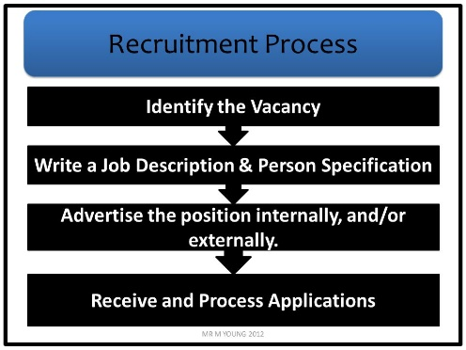**Recruitment Process:**

1. Identify a Vacancy:
2. Create Job Description
3. Create a Person Specification:
4. Put ad on website.
5. Shortlist
6. Interview
7. Offer Job role.
8. Start Date + Contract.

**Legislation and ethics:**

When Tesco PLC is hiring its employees there are certain Ethical Procedures and Laws they must follow when considering hiring an employee.

**Employment Act 2018:**

One of the Laws that Tesco PLC must follow when considering hiring is the Employment Act 2018. This act introduces recent changes to protect employees against penalisation of their rights certain things that come under the employment act such as how Tesco PLC has a duty of care over their employees meaning to ensure the wellbeing of their employee’s and to ensure the safety of the people who work at Tesco. Another law that comes under the employment act is Policies and Procedures which means that the company [Tesco PLC] must produce polices the employees must follow and certain procedures for certain things such as maybe reporting a fellow staff member. The last thing to come under the Employment act is an Employee Contract. This is a contract the employee and the company must sign so the employee agrees to the terms and conditions of the business and that they also agree to all the policies and procedures they must follow.

**The Equality Act 2010:**

Another one of the Laws that Tesco PLC must follow when considering hiring is The Equality act. This act makes sure you cannot be discriminated for certain things you have, or you have done to yourself, and The Equality Act covers Age: this is so no matter what age you are they cannot refuse to hire you or fire you over your age. Disability: This is so the employer cannot discriminate against you if you have any sort of disability whether it be a mental disability or a physical disability. Gender Reassignment: This protects you so if you have gender reassignment surgery or identify as a different gender this protects you against you being discriminated against by your employer or colleagues. Marriage and Civil Partnership: This protects you from being discriminated against because you are married or in a Civil Partnership. Pregnancy/Maternity: This protects you against any discrimination from your employer if you are pregnant. Race: This protects you from any discrimination by your employees or employer from being targeted because of your race. Sexual Orientation: This protects you from being discriminated against for identifying as a certain gender or sexual orientation. Religion/Beliefs: This protects you against being discriminated by your employer or employee’s from being a certain religion or believing in a certain type of God. Tesco’s apply this to their workspace by not discriminating against people for their race and gender and different ethnic backgrounds and this is show and portrayed in their stores and on their website where they show and portray people from different backgrounds.

**National Minimum Wage 1988:**

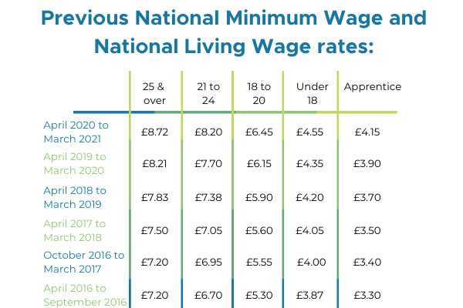Another one of the Laws that Tesco PLC must follow is the National Minimum Wage 1988. Which makes it so Tesco must pay a certain amount of money to a person otherwise it is illegal. Below is a table of the national minimum wage over the past few years:

Tesco apply this to their employee’s by showing that they pay above the minimum wage to their employee’s and even to their younger staff.

**Business Ethics:**

Group Gift and Entertainment policy.

On Tesco’s website they explain something called Group gifts and entertainment policy and they explain it as: The purpose of this policy is to provide you with guidance on what constitutes an appropriate gift or entertainment and when the receiving or giving of gifts should be avoided. The policy also sets down the Group-wide thresholds for seeking approval for gifts and entertainment and the requirements for logging them on the Gift Register. Which means that they reward staff with gifts and entertainment if they do good work at the business but only when it’s appropriate.

Group Anti-Bribery policy:

Tesco on their website explain the purpose of this policy is because.

The purpose of this policy is to set out:

Our minimum expectations for complying with anti-bribery laws; and

The obligation of every Tesco business unit to adopt and implement an effective anti-bribery compliance programme.

And they explain how they have a zero tolerance to bribes no matter their size and they said it will be punished by imprisonment or a fine

Human Rights:

Tesco believe their trade is a force for good, creating jobs and opportunities for people and communities across the world. We are committed to ensuring the jobs Tesco create and support are good jobs. It is important that clear standards are upheld on issues such as: working hours, health and safety, no child or forced labour, freedom of association and ensuring that discrimination does not take place. Tesco have a responsibility to respect the human rights of, and an opportunity to make a difference to, their colleagues, their customers, the communities Tesco operate in and the people who work throughout their supply chain.

This means they respect all the human rights policies, and they even say going against this policy could endure a fine and Immediate Termination at Tesco PLC and they even say they may ban the person depending on how bad the offence is.

**Conclusion**

Firstly, Tesco recruits via their website.

**References:**

[**https://slideplayer.com/slide/5713903/**](https://slideplayer.com/slide/5713903/)

**Tesco PLC (2023). About. [online] Tesco PLC. Available at:** [**https://www.tescoplc.com/about**](https://www.tescoplc.com/about) **[Accessed 15 Mar. 2024].**

**Wikipedia Contributors (2019). Tesco. [online] Wikipedia. Available at:** [**https://en.wikipedia.org/wiki/Tesco**](https://en.wikipedia.org/wiki/Tesco) **[Accessed 15 Mar. 2024].**

**www.equalityhumanrights.com. (n.d.). Marriage and civil partnership discrimination | EHRC. [online] Available at:** [**https://www.equalityhumanrights.com/equality/equality-act-2010/your-rights-under-equality-act-2010/marriage-and-civil-partnership#:~:text=The%20Equality%20Act%20says%20you**](https://www.equalityhumanrights.com/equality/equality-act-2010/your-rights-under-equality-act-2010/marriage-and-civil-partnership#:~:text=The%20Equality%20Act%20says%20you)

**tescoplc.com. (n.d.). Group Gift and Entertainment policy. [online] Available at:** [**https://www.tescoplc.com/sustainability/documents/policies/group-gift-and-entertainment-policy**](https://www.tescoplc.com/sustainability/documents/policies/group-gift-and-entertainment-policy) **[Accessed 15 Apr. 2024].**